SPE YP Field Trip to Wytch Farm

The SPE London Young Professionals committee had pleasure in running the SPE Geological Field Trip on the 20th May 2015. The trip consisted of a visit to the Wytch Farm Oilfield operated by Perenco UK followed by a short hike with Steve Etches along the Jurassic Coast in Kimmeridge and a tour of his impressive fossil collections.

Wytch Farm

The Wytch Farm oilfield is located 17 miles from Poole and 6 miles from Wareham in the Purbeck district, Dorset, England. It is the biggest onshore oil field in North Europe and it is a mature oil field that has been extracting oil and associated gas since 1979. The Wytch Farm oil fields comprises three separate oil reservoirs, including the Bridport and Sherwood Jurassic sandstone oil reservoirs and the Frome clay/limestone oil reservoir. Bridport, lying 900m beneath surface, was discovered in 1973. The Sherwood reservoir, situated at a depth of 1,600 m was discovered in 1978. The Frome reservoir, containing 7.5 million barrels of oil at a depth of 750m, was discovered afterwards.

The Wytch Farm oil field was discovered and initially operated by the nationalized British Gas Corporation. The first phase of the field development completed in 1980, involved four wells sites targeting the Bridport reservoir. BP, after taking over as operator of the field in 1984, upgraded the existing well sites and constructed five new well sites as part of the second phase development initiated in 1987. The field started producing from both Bridport and Sherwood reservoirs with the completion of the second phase.

The third phase of development initiated in 1993 involved extended reach drilling from the mainland under Poole Bay and the construction of a new well site on the Goathorn Peninsula. The oil production from Wytch Farm peaked at 110,000 barrels per day in 1997 compared to 6,000 barrels per day in 1984. The oil production, however gradually declined since then to 50,000 barrels per day in 2002 and today is around 18,000 barrels per day. BP, in 2011, sold its 67.8% interest in the Wytch Farm to Perenco, which further sold 17.7% to Premier. The new operator started infill drilling at the site in the first quarter of 2012.

Wytch Farm is set in an environmentally sensitive area, and various conservation laws protect most of the field. Surface operations have been hidden in coniferous forests on Wytch Heath on the southern shore of Poole Harbour and at satellite fields in Wareham and Kimmeridge bay. The gathering centre and most of the wells sites are small and well screened by trees. The smart design and use of ground flares at the gathering station, careful lighting on well sites and the separation of the distillation column into two structures reduces the vertical height and makes the field even more unique in its design. In 1995, the field won The Queen’s Award for environmental achievement and it is interesting to note that in a time of increases public awareness of industry operations in the UK, the field remains largely unnoticed by general public, just as the planners had hoped.

Wildlife habitats, plants and animals living near the oilfields have been identified through a combination of desk studies and field surveys. The main habitats in the area are heath land, coniferous woodland and unimproved grassland. Wildlife identified include important birds such as Night jar, bats, specially protected reptiles, including Smooth Snake and Sand Lizard, and a great diversity of insects.
Directional drilling has also contributed to reducing the impact on the local environment, with extended reach drilling from the Goathorn Peninsula attaining distances in excess of 10 km. The M-11 well was drilled from an onshore drill site into a reservoir that extends offshore and was brought into production on Jan 2012 at a rate of 20,000 b/d of oil. The M-11 well is the second Wytch Farm well, for which BP has claimed the world extended-reach record. The earlier M-5 well set a mark of 8.035 km.
Citing the improvements in reservoir management that have taken place since the initial reserves forecasts, Perenco anticipate that it will be economic to operate the oilfields for 20 years more than was originally supposed. In September 2012, Perenco UK applied to Dorset Country Council (DCC) for permission to extend the life of 39 planning permissions for the three oilfields. Perenco was granted permission by the Dorset County Council in September 2013 to extend the field life of Wytch Farm from 2016 to 2037.

We would like to thank Suzie Baverstock from Perenco UK, for providing such an informative tour of the field and the surrounding areas.

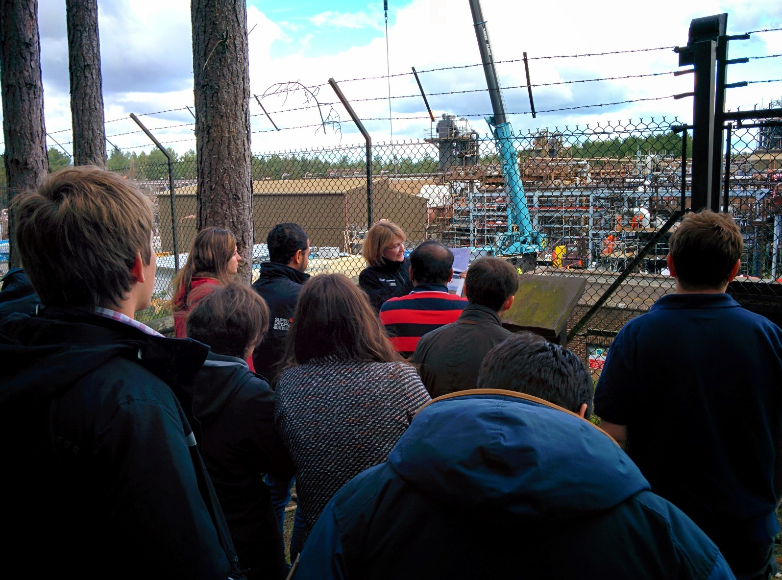

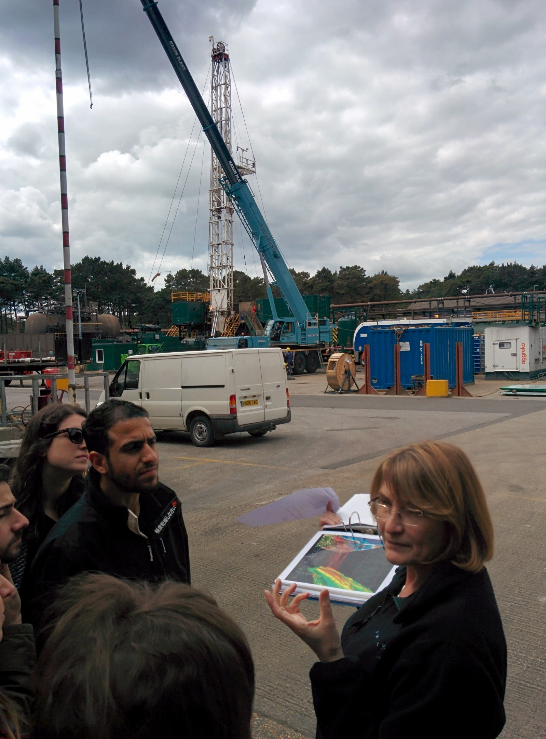

Kimmeridge - The Etches Collection
The Jurassic Coast, England’s only natural World Heritage Site is internationally renowned for the abundance of fossils on its shores. Along this famous coastline, lies the Dorset village of Kimmeridge, which has given its name to the clay formation that contains a unique range of fossils from the late Jurassic period. The Jurassic Coast covers a distance of 95 km miles with rocks recording 185 million years of the Earth’s history. World Heritage status was given to this side due to the quality of its varied geology and resulting paleontology spanning the entire Triassic, Jurassic and Cretaceous periods.
Amazing stories can be found in the cliffs and shale sediments formed 150 million years ago. A prehistoric time when pterosaurs, big and small flying reptiles ruled the skies and the first feathered birds began to appear. On land, giant eating Sauropods populated the terrain, grazing on the many species of tropical ferns and early conifers.

One man’s passion
Steve Etches is a local to Kimmeridge and has been a fossil collector for the last 30 years. He has discovered, collected and researched over 2000 incredible late Jurassic Kimmeridgian specimens. The Etches Collection is the result of one man’s passion. Over 30 years of discovery and diligent research, dogged determination not just to find and collected specimens, but also to bring to life the amazing stories of the creatures that existed in the Kimmeridgian age has resulted in the growing popularity of the collection.

A brand new immersive museum
The Etches Collection of Jurassic Marine fossils collected from Kimmeridgian clay is publically recognized to be unique and of world importance. The vision of the Kimmeridgian community is to create an engaging museum based in Kimmeridge that will benefit all while securing, conserving and enhancing the collection.
Visitors will enter the Exhibition Gallery and experience a laboratory of the senses, as they are taken on an immersive journey through life underwater 150 million years ago. The space will be transformed into an aquarium of the past in the blink of an eye; it will change from a scene of tranquility and beauty to raw, primal violence and a fight for survival. Objects that once seemed static will be brought to life and represented as if they were modern day animals.
The fossils specimens will be carefully presented and interpreted to bring to life their individual stories. Visitors will leave the museum recognizing that the fossils are tangible evidence of living being and that there are a wealth of untold stories to explore and discover as well as a lot to be learnt from this former life on earth.

Email: info@theetchescollection.org
Website: www.theetchescollection.org

